The Alix Earle Effect: The Impact of Social Media Influencers on Consumer Purchase Intention and Brand Sales

A Paper submitted to the
School of Communication and the Arts
of Gannon University

COMM 400 Senior Seminar and Thesis
Fall 2025
Ellie Malesiewski

Panelists:
Dr. Jennifer Allen Catellier, Ph.D.
MC Gensheimer
Dr. Megan Woller, Ph.D.

Presentation – December 2, 2025 12:00 pm

Introduction
75% of people use social media for purchasing advice (Digital Marketing Institute, 2025). That single data point captures why social platforms, which were once designed for connection, now sit at the center of commerce. These platforms have grown into spaces where people not only share updates but also look for product recommendations, giving influencers a big role in shaping what consumers choose to purchase.
Social media has rapidly developed into one of the most influential forms of communication in contemporary society. Although early forms of digital interaction began with e-mail lists and discussion forums in the 1970s and 1980s, the first recognizable social networking sites emerged in the late 1990s. Boyd and Ellison (2007) identify SixDegrees.com (1997) as the earliest platform to combine user profiles, friend lists, and network visibility, the features that would become the foundation of modern social networks. Throughout the early 2000s, platforms such as MySpace and Facebook expanded these features and popularized the social networking format on a global scale. Since then, social media has evolved from simple online networking tools into massive digital ecosystems where billions of users interact daily, shaping culture, commerce, politics, and public discourse.
In today’s digital landscape, marketing has shifted dramatically from traditional advertising to strategies that rely heavily on social media. One of the most powerful trends rising from this transformation is the use of social media influencers. These individuals have built large followings by creating relatable, authentic content, and their influence often extends far beyond the screen. As a result, influencers have become key players in shaping consumer perceptions, increasing brand visibility, and driving purchasing decisions. For many companies, influencer partnerships are no longer optional but a crucial component of marketing strategy, with 80% of marketers say these partnerships are good for business (Digital Marketing Institute, 2025).
The significance of influencer marketing lies in its ability to impact consumer behavior in ways traditional advertising cannot. Consumers are often skeptical of traditional advertising, but they are more receptive to recommendations from people they feel connected to online. Social media influencers hold a unique position by bridging this gap. They have communities of followers who view them as trustworthy figures, leading to stronger consumer engagement and a higher likelihood of purchase. Research shows that influencers affect consumers both emotionally and cognitively, as their content can spread positive emotions and provide useful information, leading to stronger engagement and purchase intentions (Kapoor et al., 2025). By examining this relationship, it becomes clear that influencer marketing is not just a passing trend but a crucial tactic for modern businesses.
The central argument is that social media influencers positively affect consumer purchase intentions and brand sales. This claim will be supported using the framework of Parasocial Interaction (PSI) Theory (Horton & Wohl, 1956), which explains how consumers form one-sided emotional bonds with influencers. These bonds increase trust, credibility, and the likelihood of acting on endorsements. Research confirms that higher levels of PSI significantly enhance perceptions of influencer trustworthiness and directly predict stronger purchase intentions (Lin et al., 2021). By applying this theory, it becomes possible to understand why influencer campaigns often outperform traditional advertising and how emotional connections drive tangible economic results for brands.
The analysis is organized into three main elements. The first is authenticity, a critical factor in shaping how consumers perceive influencers. When influencers present themselves as genuine and approachable, they strengthen the parasocial bond with their followers, increasing the impact of their endorsements. The second element is trust. Once authenticity is established, consumers are more likely to trust the influencer’s recommendations, leading to greater willingness to purchase the promoted product or service (Pereira et al., 2023). Finally, the third element is relatability. If consumers can see a piece of themselves in the influencer and their content, it further strengthens the bond and willingness to purchase. For businesses, the true measure of success lies in how these consumer behaviors translate into sales growth, improved brand reputation, and long-term loyalty.
This research uses the case study of Alix Earle, a rising mega-influencer whose collaborations with brands provide a clear example of these dynamics at work. By analyzing her brand partnerships, campaign outcomes, and audience engagement, the study demonstrates how authenticity, trust, and relatability directly contribute to measurable business success. The findings show that influencer marketing works well and reveal how it can help companies improve their marketing in today’s digital world.
Ultimately, this study emphasizes that social media influencers are reshaping the way consumers connect with brands. Their ability to form personal bonds with followers translates into increased trust, stronger purchase intentions, and higher brand ROI. As businesses continue to navigate the evolving marketing landscape, understanding the techniques behind influencer effectiveness will be essential for achieving long-term growth and consumer loyalty.
Literature Review
Influencer Marketing & Consumer Behaviors and Psychology
Influencers have become one of the most effective tools for shaping how consumers think, feel, and decide what to purchase. Across a large body of research, influencers consistently outperform traditional advertising in their ability to build trust and shift consumer attitudes. Han and Balabanis’s (2024) analysis of 53 studies shows that consumers respond strongly to influencers because they view them as credible, relatable, and authentic: qualities that make followers treat influencer recommendations like trusted peer advice rather than advertising. Sardar and Vijay’s (2025) review of 76 studies reinforces this finding, showing that purchase intention rises significantly when consumers view influencers as trustworthy, relatable, and aligned with their own interests. Together, these studies demonstrate that consumers don’t just passively see influencer content, they use it to guide what brands they trust and what they are willing to buy.
The persuasive power of influencers also comes from how they shape consumers’ interpretations of lifestyle, self-image, and what is considered aspirational. Foster (2022) found that influencers strategically present their lives and appearance in a way that feels both polished and “real,” which strengthens emotional connection with followers. Duffek et al. (2025) similarly found that perceptions of authenticity directly increase consumer willingness to act on recommendations. When consumers feel they “know” and trust an influencer, the influencer’s preferences begin to shape the consumer’s own preferences, often guiding them toward the products the influencer endorses.
Influencers also help consumers make sense of broader lifestyle values, and those values become tied to branded consumption. Arnesson (2022) shows that influencers seamlessly integrate sponsored content into messages about personal values, everyday decision-making, and lifestyle choices. Even when promoting services or products with political or social implications, influencers frame them as natural extensions of their daily lives, which makes followers more likely to view these products positively. Edwards (2022) showed that influencer training retreats teach influencers to present products through stories about aspiration, self-improvement, and empowerment, making followers feel like buying the product lets them participate in the influencer’s lifestyle. These strategies don’t just showcase a product, they make the product meaningful to consumers, which increases the likelihood of purchasing.
Another key reason influencers motivate consumers to buy is that many followers actively want to mimic the lifestyles, identities, and social success of influencers. Fetter et al. (2023) found that young adults often admire influencers to the point of imitation, with a large portion of users reporting they have been influenced by what influencers wear, use, or recommend, and many even aspire to become influencers themselves. This desire to mirror influencer lifestyles creates a psychological pull toward the products influencers show, because buying the same items feels like a step toward achieving the same look, confidence, or social status. Al-Zahari, Zainal, and colleagues (2023) reinforce this by showing that followers are especially persuaded by influencers they find attractive, trustworthy, and aspirational, arguing that these qualities make consumers more willing to follow their advice and more motivated to purchase endorsed products. Together, these findings demonstrate that consumer behavior is shaped not only by trust in influencers, but also by a deeper desire to identify with them, turning products into symbols of belonging and lifestyle alignment.
Instead of functioning like traditional advertisements, influencer posts blend emotions, information, and social signals that affect how consumers make decisions. Research by Kapoor, Maggon, and Gangwani (2025) shows that emotional displays such as humor, excitement, or positive storytelling can spark emotional contagion, where followers subconsciously absorb an influencer’s mood and transfer it to the brand being promoted. This research demonstrates that humorous content triggers emotional contagion while informative content increases perceived information value, and both mechanisms significantly increase brand engagement and purchase intention.
Brand Sales & ROI from Influencer Partnerships
The power of influencer marketing stems from perceived credibility and information quality. When audiences view influencers as trustworthy and their content as useful and transparent, the impact goes beyond brand favorability, it directly influences consumer spending behavior. Tuncer and Kartal (2024) found that credible influencer posts increase perceived value and justify premium pricing, illustrating how influencer marketing enhances both demand and profitability. This aligns with findings from du Plessis (2022), whose review shows that high-quality digital content strengthens trust, deepens engagement, and ultimately drives consumers toward purchasing actions that benefit the brand financially. Together, this highlights that influencer content that feels genuine and high in quality transforms traditional advertising into an interactive experience that motivates not only interest but also real purchase behavior.
Influencers also shape how people think and feel about brands through storytelling and relatable, narrative-style content. Rather than just showing a product, many influencers share experiences or journeys that make the brand feel more personal and meaningful. In the travel industry, watching brand-related vlogs has been shown to increase trust in the content, improve how people view the brand, and raise both engagement and purchase intent (Irfan et al., 2022). These effects become even stronger when viewers identify with the vlogger, seeing them as authentic, similar to themselves, or genuinely passionate about what they share, and when the information is seen as useful or inspiring. Research by De Souza and Ferris (2015) reinforces this, showing that brands in visual and lifestyle-driven sectors achieve stronger engagement and higher marketing returns when their content feels personal, visually appealing, and authentically connected to the creator sharing it. For brands, this means that influencer storytelling doesn’t just create awareness, it builds trust, shapes perceptions, and drives real consumer action, leading to long-term loyalty and financial growth.
Influencers drive not only purchasing decisions but also deep emotional and behavioral engagement with brands. Recent research shows that influencer marketing surpasses traditional advertising in trust and return on investment, with nearly half of social-media users making purchases based on influencer recommendations (Migkos et al., 2025). When endorsements feel authentic and transparent, consumers develop stronger trust and loyalty, which are two factors that sustain long-term engagement. This emotional connection is reinforced by findings from Moreira et al. (2021), who explain that brands rely on influencers specifically because their authenticity enhances brand personality, relatability, and the likelihood of repeat interaction. Together, these studies demonstrate that authentic influencer content fosters deeper relationships that translate into higher engagement rates, repeat purchases, positive word-of-mouth, and broader organic reach.
Influencer success cannot be explained by follower counts alone. Network structure and the types of social connections an influencer creates play key roles in spreading messages. In their analysis of Heineken’s “Worlds Apart” campaign, Himelboim and Golan (2019) identified three key influencer types: primary influencers with broad reach, contextual influencers who connect different online communities, and low-level influencers who share content within niche circles. Even when major brands did not directly engage, frequent mentions still amplified the campaign’s reach. This demonstrates that great marketing impact comes from a balanced influencer mix: using large accounts for visibility, bridge accounts for connectivity, and smaller creators for sustained audience engagement (Himelboim & Golan, 2019).
A study found that many companies strategically hire influencers to publicize products, reinforce brand image, and drive measurable sales growth (Moreira et al., 2021). The study revealed that platforms such as Instagram and Facebook were preferred because of their wide reach and interactive nature. The authors also explained that influencer results can be measured using tools like Google Analytics, discount codes, and website traffic to track campaign success and consumer response. These insights show that influencer marketing provides both emotional and economic benefits: it strengthens consumer-brand relationships while delivering measurable returns on investment. The authors conclude that influencers act as a bridge between brands and consumers, turning one-way marketing into two-way communication that builds brand loyalty.
Finally, an effective influencer strategy should fit the communication context. In times of controversy or crisis, it’s not just about choosing influencers who know the product, it’s about choosing those whose tone, values, and emotions match the brand’s message. When influencer traits and emotions align with how a brand wants to be perceived, it can help protect reputation and reduce negative reactions (Mishra & Maheshwari, 2025). While this idea comes from crisis communication research, it also applies to everyday marketing decisions, especially when brands engage with social or sensitive topics where emotional alignment is key.
Brands benefit from influencers in several connected ways. Influencer marketing merges emotion, communication, and commerce into a single space that fuels measurable brand success. By blending personal credibility with creative storytelling, influencers transform brand promotion into meaningful interaction. Their ability to connect with audiences on a human level converts visibility into trust and engagement into sales. More than a short-term advertising tool, influencer partnerships function as long-term investments by building communities, strengthening brand identity, and driving sustained financial returns in an increasingly relationship-driven marketplace.
Parasocial Interaction Theory
Parasocial Interaction (PSI) Theory (Horton & Wohl, 1956) explains how audiences form one-sided yet emotionally meaningful relationships with media figures, perceiving them as real friends despite limited or no direct contact. In influencer marketing, PSI occurs when followers engage with influencers’ content in ways that simulate interpersonal closeness, such as commenting, liking, or responding as if in mutual conversation. These interactions trigger psychological attachment, which influences attitudes toward both the influencer and the brands they endorse (Lee & Lee, 2022). When viewers experience emotional intimacy, they begin to see influencers not as advertisers but as trusted companions whose opinions carry personal weight (Chung & Cho, 2017). The strength of these parasocial bonds can be understood through three key elements: authenticity, relatability, and trust, which together explain how influencers convert attention into emotional connection.
Authenticity is the foundation of PSI. When influencers communicate openly, sharing real experiences, opinions, and even vulnerabilities, they appear genuine and approachable, helping audiences feel part of their private world (Chung & Cho, 2017). This transparency builds emotional engagement and strengthens the illusion of friendship. Kim, Shoenberger, and Sun (2021) found that trusted influencers generate greater enjoyment and engagement with sponsored content, especially when their posts align with their true personality. Likewise, Dinh, Wang, and Lee (2023) showed that followers often mimic influencers they see as authentic role models, illustrating how sincerity shapes both emotional connection and purchase intention.
Relatability and trust deepen this connection. When audiences see influencers as “people like me,” parasocial bonds strengthen through shared values and lived experiences. Dewantara et al. (2025) found that perceived similarity heightens engagement and makes influencer messages feel more like genuine recommendations than paid promotions. Kim and Kim (2023) similarly describe relatability as a form of social capital that builds loyalty and community participation. Over time, consistent authenticity and transparency lead to trust. Through repeated honesty and self-disclosure, influencers become credible sources whose recommendations feel personally reliable (Lee & Lee, 2022). This trust transforms one-way communication into two-way interactions, motivating followers to act because they believe in the influencer’s authenticity.
In essence, Parasocial Interaction Theory shows that influencers are most effective when they build emotional connections through authenticity, relatability, and trust. These elements make online interactions feel more human, turning simple content viewing into genuine relationships that inspire engagement, loyalty, and real consumer action.
Method
To understand how parasocial relationships between influencers and followers shape consumer behavior, this case study focuses on Alix Earle’s collaboration with the beverage brand Poppi. The partnership between Earle and Poppi began in 2024 and is still ongoing today. It gained significant attention across TikTok and Instagram, where Earle’s casual and transparent approach to promoting the product contributed to an authentic and relatable campaign. Parasocial Interaction (PSI) Theory (Horton & Wohl, 1956) provides the framework for this study, explaining how audiences form one-sided yet emotionally meaningful bonds with influencers that mimic real friendships. These emotional bonds influence how consumers interpret brand messages, perceive credibility, and make purchase decisions. The goal of this research is to explore how authenticity, relatability, and trust, three central elements of PSI, emerge throughout the campaign and how they contribute to audience engagement, consumer purchase intentions, and brand success.
Sample
The sample for this case study consisted of Alix Earle’s TikTok and Instagram posts promoting Poppi, as well as Poppi’s own TikTok and Instagram posts featuring or referencing Alix. The posts selected represented a range of contexts in which Poppi appeared, including casual girls’ nights, Coachella festival content, everyday lifestyle moments, general brand promotion, “get ready with me” videos, and posts highlighting her own branded Poppi cans. A post announcing her investment in Poppi was also included due to its significance in shaping consumer trust. The sample included both sponsored advertisements and organic mentions where Poppi appeared naturally in Earle’s content. Audience comments on these posts were examined to capture consumer reactions and engagement. User-generated content related to the collaboration was also assessed to illustrate how Earle’s influence extended beyond her own accounts.
Alongside social media content, secondary information such as Google search trends for terms like “Poppi” and “Alix Earle Poppi,” as well as available sales data from the campaign period, was reviewed to contextualize how online engagement may have translated into consumer behavior. In total, approximately 15 posts and their corresponding comment sections (five comments per post) were analyzed to ensure depth, variation, and representation across platforms.

Procedure
This study will use a qualitative case study and content analysis approach. Data will be collected by reviewing Alix Earle’s and Poppi’s official TikTok and Instagram accounts to identify posts related to their collaboration. Relevant videos, photos, and captions that feature or mention Poppi will be selected for analysis, along with the accompanying audience comments and engagement metrics. Posts and comments will be coded according to three themes from Parasocial Interaction Theory: authenticity, relatability, and trust.
Coding will be done by reviewing each post and comment section to identify patterns in tone, setting, language, and audience response. Engagement data such as likes, shares, and views will also be noted to understand how audience reactions connect to these themes. Finally, Google search trends and available Poppi sales data will be reviewed to see whether consumer interest increased during the campaign period.
Measures
Three primary measures will guide the analysis, drawn directly from Parasocial Interaction Theory. Authenticity refers to how genuine, transparent, and unscripted Earle’s content appears. Indicators of authenticity include open communication, casual presentation, and personal storytelling that make her seem approachable and real (Chung & Cho, 2017). Relatability is defined as the extent to which audiences perceive shared experiences, humor, or lifestyle similarities with the influencer. This may appear through self-deprecating humor, everyday settings, or comments expressing identification, such as “She’s just like me” (Kim & Kim, 2023). Trust reflects the belief that the influencer’s recommendations are credible and sincere, shown through consistent messaging, honest product reviews, and audience comments expressing confidence in her opinions (Lee & Lee, 2022).
For example, a comment like “I love Poppi because of Alix” will be coded as trust, while a casual, at-home video may represent authenticity. Each post and comment will be analyzed for the presence or absence of these three measures to determine how authenticity, relatability, and trust work together to create parasocial bonds that influence audience engagement and consumer behavior surrounding the Poppi brand.
Results
Analysis
RQ1: How do influencers affect consumer purchase intention through parasocial interactions?
Parasocial Interaction Theory was applied through the analysis of Alix Earle’s collaboration with Poppi to measure how authenticity, relatability, and trust influence consumer purchase intentions. The case study examined 15 posts total: five from Alix Earle’s TikTok and Instagram accounts, five from Poppi’s official social pages, and five user-generated posts (UGC) from everyday consumers referencing the collaboration. Each post and five of its comments were reviewed for how audiences responded to Earle’s content, tone, and overall presentation of the Poppi brand.
The findings revealed that authenticity was the most dominant theme in Earle’s posts. She regularly presented Poppi naturally in casual settings, often at home, during her “get ready with me” videos, or incorporating the drink into her lifestyle and daily routine. This style of content matched her usual tone and created a sense of normalcy that made the promotion appear genuine rather than sponsored. For example, Figure A below shows an Instagram post of Alix Earle during a typical girls’ night out, casually holding and drinking Poppi, presented as a natural part of her evening rather than a formal advertisement. Comments such as “I have to try this Poppi” and “I love you and Poppi so much” reflected viewers’ genuine enthusiasm and belief that Alix’s use of the product was authentic and sincere.
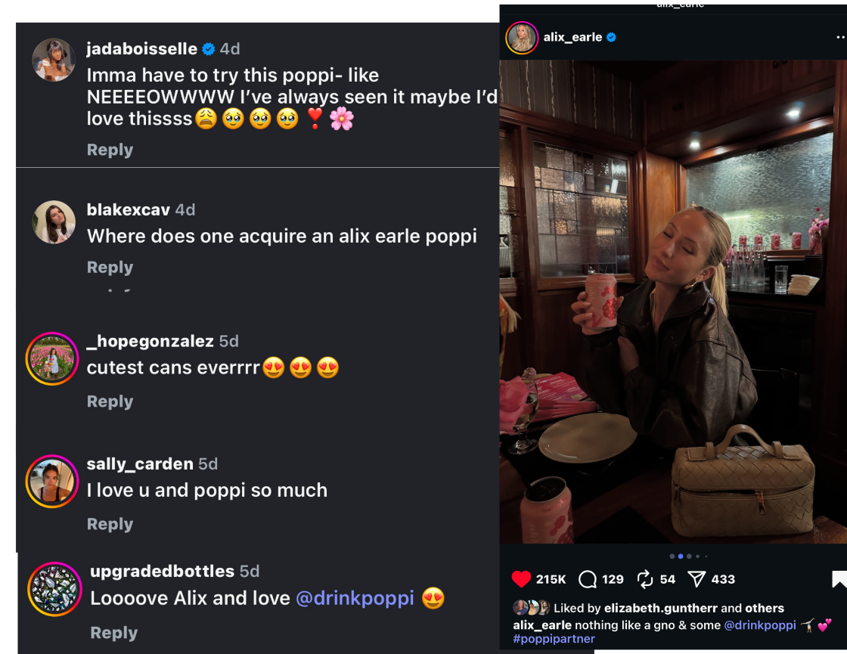Figure A
Another strong example of authenticity appeared in a post where Alix visited her family’s ice cream shop and used Poppi soda to make an ice cream float alongside her younger sisters (Figure B). The setting felt natural and nostalgic, showing a genuine family moment rather than a polished advertisement. Earle’s relaxed demeanor and playful interactions with her sisters made the collaboration feel personal and heartfelt, reinforcing her reputation for being down-to-earth. Comments such as “Your sisters are so cute” and “I need to try that float now” reflected how audiences connected with both the family dynamic and the sincerity of the promotion. This post demonstrated how authenticity, when paired with genuine personal storytelling, can turn a brand partnership into a relatable and emotionally engaging moment.
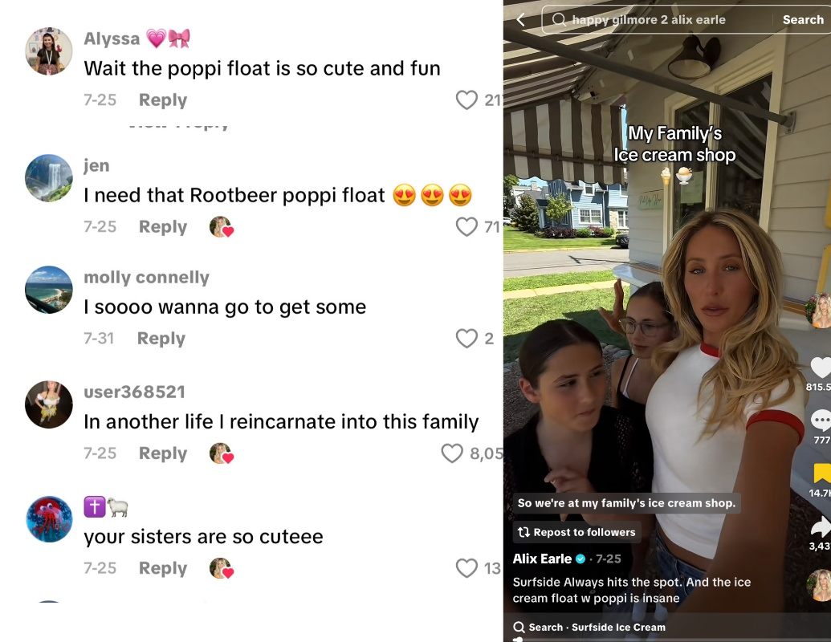Figure B
Relatability was another strong factor throughout Earle’s content, particularly in posts where she promoted Poppi in real-life, social settings. In a carousel Instagram post from Coachella (Figure C), Alix was seen hanging out with friends and casually sipping a new Poppi flavor, blending the brand seamlessly into a fun, authentic moment rather than a staged advertisement. Her informal tone, humor, and carefree energy reflected the same lifestyle her followers aspire to, allowing viewers, especially Gen Z audiences, to see her as “one of them.” Comments such as “Love Poppi, gotta try this new flavor!” and “Where do I get a fridge full of Poppi, I need that” showed how audiences identified with her experiences. This sense of relatability that Alix often uses transformed what could have been a standard sponsorship into a genuine, lifestyle-based recommendation that made Poppi feel both trendy and attainable.
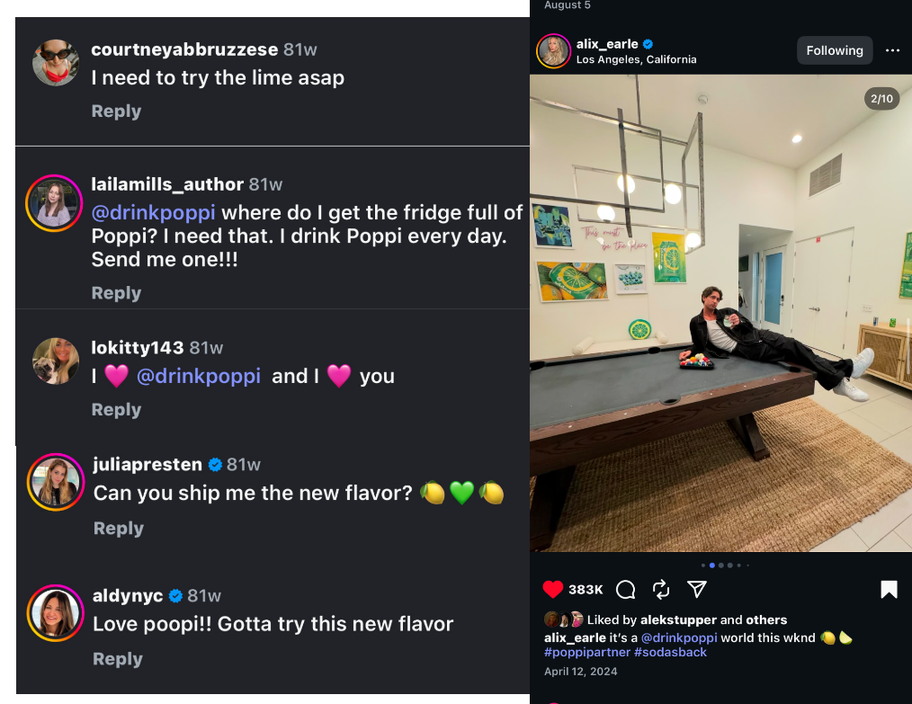Figure C
Trust emerged through repeated exposure and consistent messaging. Alix Earle has been a partner with Poppi since early 2024, and still remains a partner today. Because Earle had already built credibility as a lifestyle influencer, audiences viewed her endorsement of Poppi as believable and sincere. Followers often referenced her reliability, saying, “If Alix says it’s good, it’s good,” or “So happy with this collab.” Poppi’s own posts that show Alix Earle also received higher engagement than typical brand posts, suggesting that her credibility directly enhanced brand performance. In general, posts featuring her image or referencing her content style achieved notably higher likes and shares compared to standard marketing graphics. This reflects how influencer-brand collaborations merge personal branding with corporate marketing in a way that feels more organic and emotionally driven.
Another clear example of trust can be seen in Figure D below, when Alix announced that she had officially become an investor in Poppi. Rather than feeling like a traditional endorsement, this announcement reinforced her long-term belief in the brand and validated the authenticity of her previous promotions. Followers responded positively, viewing her investment as proof that she genuinely supports and believes in the product she’s been sharing. Comments showed that people viewed her investment as evidence that she genuinely believes in the product she’s been sharing, which enhanced the overall credibility of both Alix and Poppi. General excitement and trust can be seen by comments such as “Alix drinks Poppi so I drink Poppi” and “I’m so happy that you are part of the company.” By aligning her personal brand with Poppi on a financial and emotional level, Earle strengthened the parasocial trust between herself and her audience, showing that her connection to the brand extends beyond sponsorship into genuine partnership.
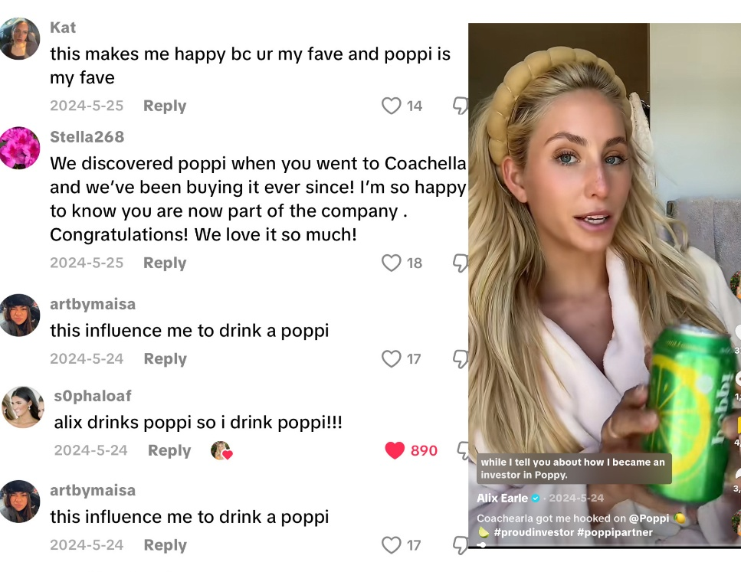Figure D
User-generated content further illustrated the strong influence of Earle’s collaboration with Poppi. Many consumers created their own videos inspired by her posts, showing genuine excitement about the brand. For example, Figure E shows an unboxing video featuring a user enthusiastically opening a Poppi package, expressing how much they love the Alix-branded cans. Comments on the post echoed that excitement, with users writing things like “Convinced me to get some” and “This collab is so cute.” Another popular UGC post (Figure F) showed a viewer holding a Poppi can while saying they were “only watching the Super Bowl for the Alix x Poppi commercial.” This type of content demonstrated how Earle’s influence extended far beyond her own audience, sparking a community of consumers who not only purchased the product but also proudly shared their experiences online. These examples show how parasocial relationships can evolve into active brand participation, as audiences begin to replicate influencer behavior and reinforce brand loyalty through peer engagement.
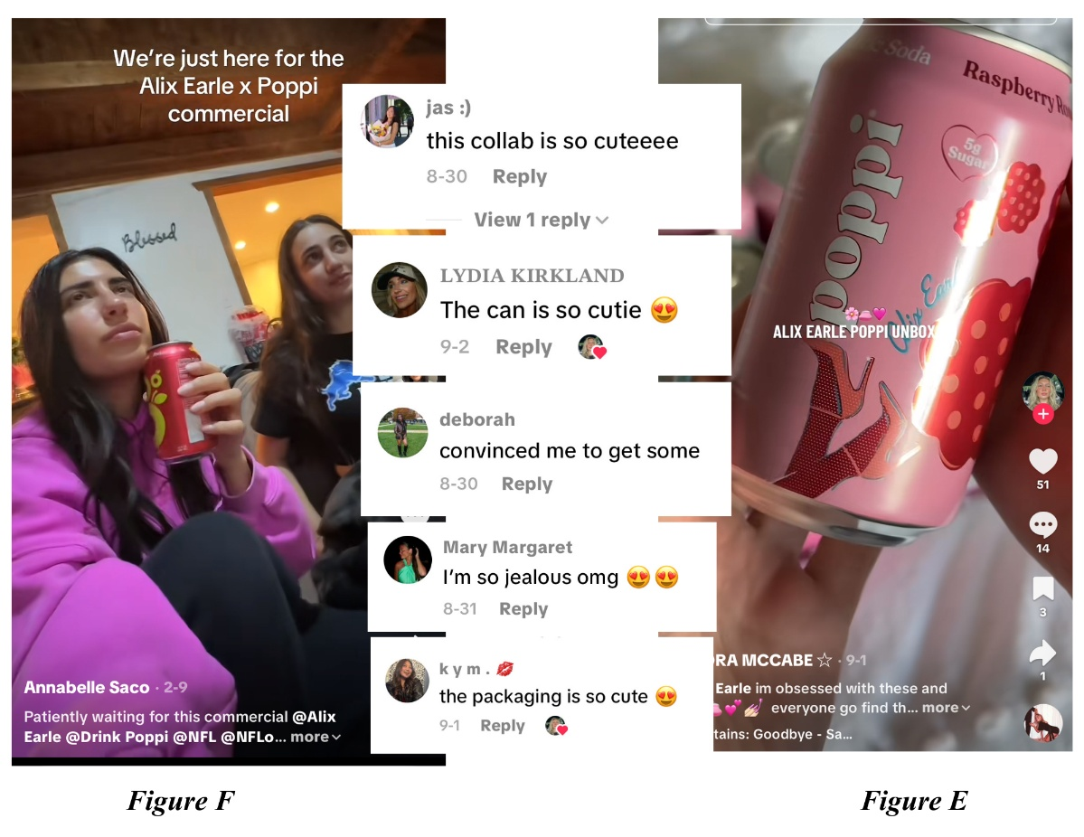
Hypothesis: Brands that collaborate with social media influencers experience higher ROI than brands that do not.
As seen in figure G below, available sales data indicated that Poppi experienced significant sales growth between 2023 and 2024 (Tap Twice Digital, 2025). While this study cannot attribute those increases directly to Alix Earle’s involvement, the timing of her collaboration coincided with periods of rising brand visibility online. The consistency of her Poppi-related posts, combined with high engagement and widespread consumer-created content, appeared to reflect elevated interest in the brand during the collaboration period.
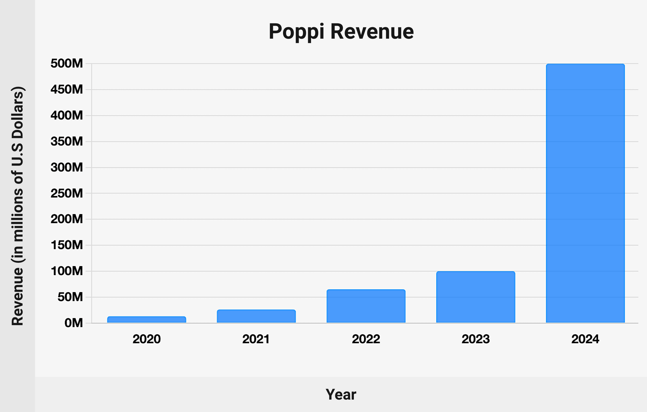Figure G
Google search data also helped show how visible the collaboration was over time. When searching “Alix Earle Poppi,” different date filters produced different result counts. For example, 29,300 results from February 2024 to July 2025, 112,000 results when set to “Any time,” and about 8,130 results when the filter was set between September 2022 and February 2024. These numbers show that a large amount of online content mentioning both Alix and Poppi existed across multiple time ranges. Periods when Alix posted more Poppi-related content, such as the launch of her Poppi flavor, her Coachella activation, and her announcement that she became an investor, also appeared to match times when searches were more active. While this does not show direct causation, it suggests that higher influencer activity may be connected to increased online growth or curiosity about the brand.
Taken together, these examples suggest that influencer partnerships especially grounded in authenticity, relatability, and trust, may play a meaningful role in shaping consumer attention and purchase intentions. The alignment between Earle’s promotional periods, search volume trends, and broader brand momentum is consistent with the hypothesis.
Discussion
The findings of this study suggest that influencer collaborations can meaningfully shape consumer interest and engagement, supporting the idea that social media personalities play an important role in purchasing behavior. Poppi’s partnership with Alix Earle created a blend of lifestyle content and subtle product integration that resonated strongly with her audience. Rather than feeling like traditional advertising, her posts came across as natural extensions of her daily life. This type of integration aligns with research showing that influencer marketing delivers stronger emotional impact, higher trust, and better ROI compared to traditional advertising (Migkos et al., 2025).
The results also support the hypothesis that brands collaborating with influencers tend to experience stronger returns on investment. While the study cannot determine direct causation, the patterns observed show that periods of high influencer activity were paired with significant online interest, large volumes of search results, and increased consumer discussion. This echoes research indicating that influencer partnerships often drive higher engagement, stronger brand recall, and measurable increases in visibility (Moreira et al., 2021). These are key markers of ROI in digital marketing. Poppi’s strategic decision to partner with Alix Earle appears consistent with the literature suggesting that influencer collaborations contribute to more brand awareness and growth even if outcomes cannot be attributed to the influencer alone.
The widespread user-generated content also highlights how influencer campaigns extend beyond the original posts. Fans recreated Alix’s Poppi moments, shared their own Poppi purchases, and even brought the product into cultural events, such as drinking Poppi while watching the Super Bowl commercial featuring Earle. This reflects broader research showing that when audiences identify with an influencer and observe others mimicking their behavior, social proof strengthens and perceived product value rises. Fetter et al. (2022) found that young adults frequently imitate influencers’ consumption habits, adopting the same products as a way to align with the influencer’s lifestyle and social identity, which directly increases purchase intentions. Poppi’s user-generated surge shows how influencer-driven mimicry amplifies brand reach, reinforces desirability, and fuels real buying behavior.
Alix’s presence in 2025 Super Bowl commercials further expanded her influence beyond social media. She appeared not only in Poppi’s nationally aired commercial but also featured in Hellmann’s “When Harry Met Sally” themed campaign and Carl’s Jr.’s post-game burger promotion ad. These high-profile appearances positioned her in front of a massive national audience. This crossover into mainstream advertising highlights how brands leverage influencer familiarity as a strategy for improving brand recall and cultural relevance.
The Alix Earle x Poppi Internship shows how closely Earle’s identity has become tied to the brand. The paid summer program required applicants to submit a creative video, turning the application process into a UGC moment that matched Poppi’s social-first marketing style and attracted strong participation from students. Earle’s influence also extends beyond beverages. Items she casually uses, like her portable phone light, have sold out after appearing in her videos, showing broad consumer responsiveness. By centering an internship around her persona and benefiting from her ability to drive interest across categories, Poppi positioned Earle as a long-term part of its brand strategy. This pattern aligns with findings from De Souza and Ferris (2015), who show that brands gain stronger engagement and higher marketing returns when audiences feel personally connected to the creator presenting the content.
Consumers expressed higher trust and excitement in Poppi’s brand when Earle’s personality and content tone aligned with her usual style, reinforcing the idea that parasocial relationships are built through perceived authenticity and emotional intimacy. The presence of UGC and recurring consumer comments further validates that followers are not only persuaded by influencer marketing but are also motivated to participate in it. Overall, these findings show that Alix Earle’s collaboration with Poppi effectively leveraged authenticity, relatability, and trust, three components of Parasocial Interaction Theory, to create measurable consumer engagement. The results illustrate that social media influencers impact purchase intentions not through direct sales pitches, but by forming emotional connections that humanize brands and turn audiences into active participants in brand storytelling.
Practical Applications, Future Research, & Limitations
Marketers can use this research when developing influencer strategies or deciding whether to partner with creators. The results show that when influencers integrate a product naturally into their content, as Alix Earle did with Poppi, brands can benefit from stronger engagement and increased consumer interest. This suggests that companies should choose influencers whose personalities and content styles already match the brand’s identity. Campaigns that encourage user-generated content, such as Poppi’s internship, can also extend reach and deepen audience involvement.
Future research on influencer partnerships should consider three areas. First, which industries see the strongest impact from influencer collaborations, and how does this vary across different types of creators? Second, which influencers are most effective for specific brand categories, since lifestyle influencers may not perform the same as beauty or fitness creators? Lastly, researchers should explore which platforms are currently most effective for influencer-driven marketing, as trends shift quickly across TikTok, Instagram, YouTube, and other social channels. Answering these questions will help marketers stay aligned with changing consumer behaviors.
This study had a few limitations. The analysis relied on a small sample of posts and comments, which limits how broadly the findings can be applied. The research also used publicly available data, making it difficult to fully understand the demographics or motivations of commenters. Additionally, while online search activity, sales, and engagement aligned with Earle’s promotional periods, this study cannot determine direct causation. However, the results still offer useful insights for understanding influencer impact.
Conclusion
This study demonstrates that social media influencers play a significant role in shaping consumer purchase intentions and driving measurable brand outcomes. Through the lens of Parasocial Interaction Theory, it becomes clear that authenticity, relatability, and trust are the psychological mechanisms that make influencer marketing so effective. Alix Earle’s collaboration with Poppi provided a clear example of how these elements work together: her casual integration of the product into her everyday life, her consistent messaging, and the sense of emotional closeness she has with her audience created powerful parasocial bonds that encouraged consumer engagement. These connections translated into visible behavioral outcomes, such as user-generated content, increased online searches, and heightened brand interest; all indicators of elevated consumer intention and brand momentum.
The research also highlights that influencer marketing extends beyond personal storytelling into broader brand strategy and financial impact. Poppi’s strategic use of Earle, not only as a promotional partner but as a brand ambassador, investor, and centerpiece of campaign initiatives like the Poppi Internship, reflects how influencers can shape brand identity and serve as long-term assets. The widespread UGC, the resonance of her Super Bowl appearances, and the alignment between her personal brand and Poppi’s values all support the hypothesis that influencer partnerships can strengthen brand awareness, improve consumer perceptions, and contribute to higher brand ROI.
Ultimately, this study shows that influencers do more than promote products, they humanize brands. Through authentic communication and emotional connection, they make brands feel accessible, trustworthy, and culturally relevant. As social media continues to dominate consumer decision-making, influencers will remain essential to how companies build relationships, cultivate loyalty, and drive purchase behavior. Understanding the psychological foundations of their influence will be critical for marketers seeking to navigate an increasingly digital and relationship-driven marketplace.

References
Al-Zahari, N. S., Zainal, N. Z., Abu Seman, S. A., & Salleh, N. F. (2023). Influence unleashed: How social media influencers' credibility drives viral success. Global Business and Management Research, 15(4S), 84–95.
Arnesson, J. (2022). Influencers as ideological intermediaries: Promotional politics and authenticity labour in influencer collaborations. Media, Culture & Society, 45(3), 528–544.
boyd, d. m., & Ellison, N. B. (2007). Social network sites: Definition, history, and scholarship. Journal of Computer-Mediated Communication, 13(1), 210–230.
Chung, S., & Cho, H. (2017). Fostering parasocial relationships with celebrities on social media: Implications for celebrity endorsement. Psychology & Marketing, 34(4), 481–495.
De Souza, I. M., & Ferris, S. P. (2015). Social media marketing in luxury retail. International Journal of Online Marketing, 5(2), 18–32.
Dewantara, M. H., Jin, X., & Gardiner, S. (2023). What makes a travel vlog attractive? Parasocial interactions between travel vloggers and viewers. Journal of Vacation Marketing, 31(1), 113–129.
Digital Marketing Institute. (2025). 20 surprising influencer marketing statistics. https://digitalmarketinginstitute.com
Dinh, T. C. T., Wang, M., & Lee, Y. (2023). How does the fear of missing out moderate the effect of social media influencers on their followers’ purchase intention? SAGE Open, 13(3).
Duffek, B., Eisingerich, A. B., Merlo, O., & Lee, G. (2025). Authenticity in influencer marketing: How influencers and brands work together to build and maintain influencer authenticity. Journal of Marketing, 89(5), 21–46.
Edwards, S. (2022). Branded dreams, boss babes: Influencer retreats and the cultural logics of the influencer para-industry. Social Media + Society, 8(3).
Fetter, S., Coyne, P., Monk, S., & Woodruff, S. J. (2023). An exploration of social media users’ desires to become social media influencers. Media Watch, 14(2), 200–216.
Foster, J. (2022). “It’s all about the look”: Making sense of appearance, attractiveness, and authenticity online. Social Media + Society, 8(4).
Han, J., & Balabanis, G. (2024). Meta-analysis of social media influencer impact: Key antecedents and theoretical foundations. Psychology & Marketing, 41, 394–426.
Himelboim, I., & Golan, G. J. (2019). A social networks approach to viral advertising: The role of primary, contextual, and low influencers. Social Media + Society, 5(3).
Horton, D., & Wohl, R. (1956). Mass communication and para-social interaction: Observations on intimacy at a distance. Psychiatry, 19(3), 215–229.
Irfan, M., Malik, M. S., & Zubair, S. K. (2022). Impact of vlog marketing on consumer travel intent and purchase intent with the moderating role of destination image and ease of travel. SAGE Open, 12(2).
Kapoor, P. S., Maggon, M., & Gangwani, K. K. (2025). Inform me or make me laugh: Influencer marketing and the role of emotional contagion and information value. International Journal of Consumer Studies, 49, e70005.
Kim, E., Shoenberger, H., & Sun, Y. (2021). Living in a material world: Sponsored Instagram posts and the role of materialism, hedonic enjoyment, perceived trust, and need to belong. Social Media + Society, 7(3).
Kim, Y., & Kim, S. (2023). Motives for following social influencers and electronic word-of-mouth: The role of social capital. International Journal of Communication, 17, 7093–7116.
Lee, M., & Lee, H.-H. (2022). Do parasocial interactions and vicarious experiences in beauty YouTube channels promote consumer purchase intention? International Journal of Consumer Studies, 46, 235–248.
Lin, C. A., Crowe, J., Pierre, L., & Lee, Y. (2021). Effects of Parasocial Interaction with an Instafamous Influencer on Brand Attitudes and Purchase Intentions. The Journal of Social Media in Society, 10(1), 55+.
Migkos, S. P., Giannakopoulos, N. T., & Sakas, D. P. (2025). Impact of influencer marketing on consumer behavior and online shopping preferences. Journal of Theoretical and Applied Electronic Commerce Research, 20(2), 111.
Mishra, D., & Maheshwari, N. (2025). Influencer alignment in crisis response: Trait and emotional congruence for brand reputation recovery. Journal of Contingencies and Crisis Management, 33, e70068.
Moreira, I., Stenzel, P., Lopes, J. M., & Oliveira, J. (2021). Do digital influencers successfully contribute to reducing the gap between customers and companies? Brazilian Business Review, 18(6), 662–680.
Pereira, M. J. de S., Cardoso, A., Canavarro, A., Figueiredo, J., & Gaspar, J. E. (2023). Digital influencers’ attributes and perceived characterizations and their impact on purchase decisions. Sustainability, 1–17.
Sardar, H., Li, Y., & Abbas, A. (2025). Social media influencers and purchase intention: A review and research agenda. International Journal of Consumer Studies, 49(3), 345–363.
Tuncer, İ., & Kartal, A. S. (2024). Do the importance of influencer- and customer-generated content on social media affect willingness to pay more for potential customers? Journal of Consumer Behaviour, 23(2), 1002–1013.

